EFFECTS OF MULTIPLE WAY COMMUNICATION IN BUSINESS WORKING FOR EMPLOYEES

Prepared for
Shari Weiss

Prepared by
Jun Yuan Cai

October 30/2018
TABLE OF CONTENTS

LIST OF ILLUSTRATIONS iii
EXECUTIVE SUMMARY iv
INTRODUCTION: HOW EMPLOYEE COMMUNICATION IN WORKING 1-2
FINDINGS:
TWITTER AND FACKBOOK 3
MULTIPLE DIVICES PEOPLE 4
Majority of Americans now use Facebook, YouTube 5

Function of those social media 6

CONCLUSIONS AND RECOMMENDATIONS 7
WORKS CITED 8
QUESTIONNAIRE 9-10

LIST OF ILLUSTRATIONS

Figure 1: TWITTER AND FACKBOOK 3
Figure 2: MULTIPLE DIVICES PEOPLE 4
Figure 3: Majority of Americans now use Facebook, YouTube 5
Figure 4: Function of those social media 6

EXECUTIVE SUMMARY

Social media today is one of the most important tools a business can use. Specifically, for some small business more and more social media is used because small companies have no extra money for creating their own communication system, even some of the business require employees bring their devices to work, which helps them saving a part of their consumption. Moreover, some people believe that using personal devices can improve their working ability because they know more their devices than the one that companies provided. As a result, employees use multiple devices in working is normal in order of this environment.
However, using multiple devices to communicate in working environment doesn’t mean employees working ability that will increase multiply, but the opposite that too much devices for communicating can create efforts. For example, employees need to use many different social media to communicate with their co-worker because they are using different devices and social media that some people use email because they are using computer as communication tool, but some people might use Facebook as communication tool because they are using cell phone as device for communicating. As a result, when people are using a stranger system, it can cause a lot unnecessary mistake. It can be pressing the wrong button, sending wrong information to their co-workers, even deleting wrong file in their own devices.
This report has found that every business should have a strong social media presence, a team to run it, and protocol to follow when using it. Through these relatively small actions, if managed well, a huge increase in customer retention can be seen. Through the new found a ton of people are using Facebook and twitter.
INTRODUCTION
Background
Large industrial organizations have a long history of promoting pride and a sense of unity among the employees of the company, evidenced in the cultural productions of Victorian-era soap manufacturers as far apart as the UK's Lever Brothers (right) and the Larkin Soap Company of Buffalo, New York.
Internal communications are fundamentally a management discipline, but as a discrete discipline of organizational theory it is correspondingly young. Stanford associate professor Alex Heron's Sharing Information with Employees (1943) is an outlier among texts which focus solely on the factors involved. Theorization in academic papers accelerated in the 1970s, but mainstream management texts mostly post-date 1990.
Writing in 2013, Ruck and Yaxley explore how the discipline evolved from the days of employee publications in the late 19th century. As organizations became more complex, the impetus to communicate with employees grew and led to the emergence of an increasingly specialized discipline.

Purpose
Social media for business is one of the most powerful tools of the modern age and there is business that are either not taking part or poorly using social media. This report will show how important having an active social media presence can be to not only boost sales but also handle employees’ communication.

Significance
using multiple devices to communicate in working environment doesn’t mean employees working ability that will increase multiply, but the opposite that too much devices for communicating can create efforts. Using one way in business communication can increase employee’s communication efficiency.
Scope
This report will cover the benefits of social media presence for company, including Instagram, Facebook, and Twitter. Many different companies showing that their employees are not only using multiple devices in communication, but also multiple social media. The report will focus on the benefits of company social media presence and not focus on one way.
Organization
The discussions will mostly cover how essential it is for companies to have social media presence. In doing so there will be example of how strong social media team having has helped the company such as Facebook and Twitter.

FINDINGS
The most used social media
From the Figure #1, Although there a huge amount of different social media and device are being used in the world, but the most people used is face book and twitter, which are both access by mobile. It Is increasing in the future also that there will have more and more people using mobile app. Twitter and Facebook will have huge potential for the future company communication tool.
Figure #1
It is a lot of social medias in mobile, but Twitter and Facebook still contain a huge number of costumers.
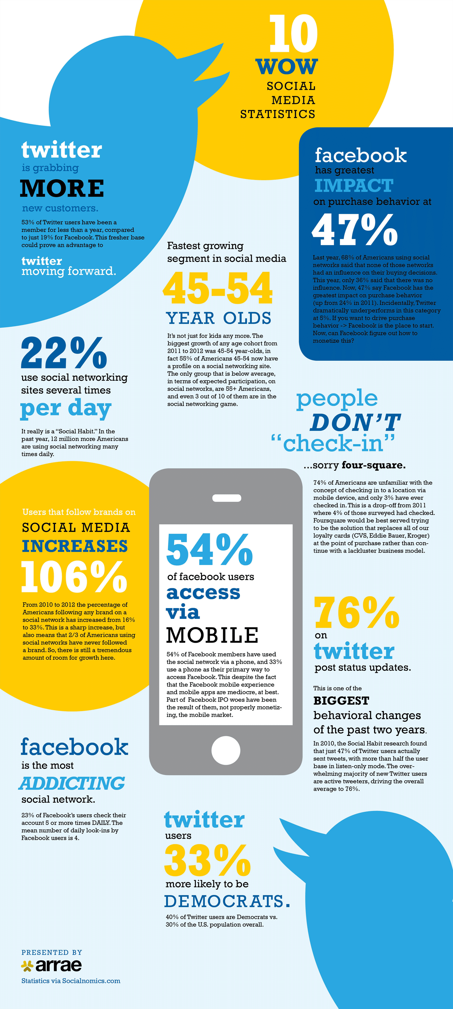

Source: http://www.bitrebels.com/wp-content/uploads/2012/10/social-media-stats-wow-infographic.png
Designed by Arrae
Percentage of people using different devices in working
On October 11, 2017, a survey shows that huge amount people using multiple devices while they are in the working place. As the figure #2 shows that 58% people are using Mobile apps and 45% people are using Social media for communication. It is not difficult to find out social media and mobile apps are the most popular way for communication around employees’ environment.

Figure #2
It is a table that shows people are using multiple devices for communication in working environment.
Mobile apps | 58%
Social media | 45%
Web-collaboration tools | 34%
Wireless connectivity | 32%
Smartphones | 29%
Content management system | 25%
Workplace infrastructure | 25%
Wearable technology | 22%
Tablets | 9%

Source: https://insights.staffbase.com/blog/11-ideas-how-to-rethink-internal-communication
design by Sina Kaye Lockley

Majority of Americans now use Facebook, YouTube

Today, more and more people are using mobile app, and social media is the one that are most common be used in people’s daily live. In the following figure, 68% adults use Facebook which is the second one be used the most, and it is double of the third one, Instagram
Figure #3
A chart shows the most percentage social media use Facebook.

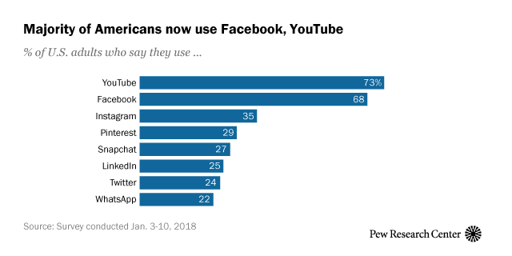

Source: http://www.pewinternet.org/2018/03/01/social-media-use-in-2018/
Designed by AARON SMITH AND MONICA ANDERSON
Function of those social media
A great social media team is developed over time and can-do great work for business communication. As shown in figure 4 Facebook and twitter can share to your latest email and share a photo of customers shopping small. Both are good way to communicate internal in a company.
Figure #4
A gird Show the function of those social media.

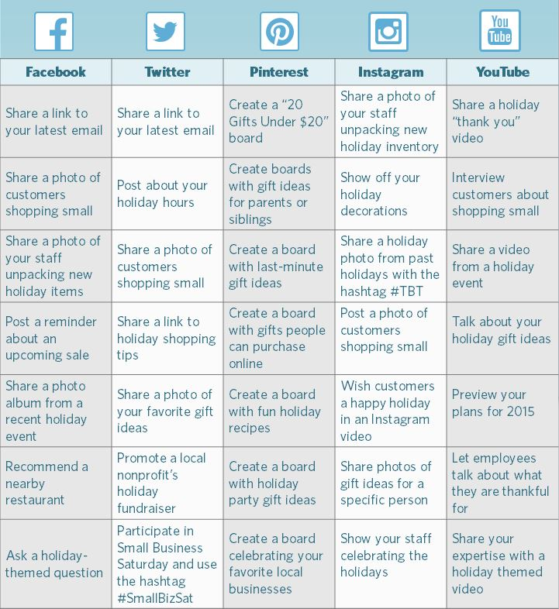

Source: http://edmistongroup.com/tag/social-media-plan/
Designed by edmiston
Conclusion and Recommendation

Conclusion for employers
As shown in the various examples throughout this report social media today is one of the most important and powerful tools a business can use. Using one social media can decrease cost of communication that a perfectional social media is already being used by huge amount people, and it is tested by a professional team. People should choose one of social media that is used most in their company because different people might have different habit that different area can have different popular social media. Using one powerful social media can help employee’s internal communication, but not too much.

Recommendation for employers
The first to getting into social media is hiring someone with knowledge of the most common platforms, such as Twitter, Facebook, and Instagram. Once there is a person or team to support the company. It is easily to do the following step. Employees also need to have a following guide which can help them to use the new social media. Pictures of the best destinations, stories of employee hard at work, or meeting satisfied customers are a few great ways to connect with the co-worker.

City work

https://en.wikipedia.org/wiki/Internal_communications#History_of_internal_communications

http://www.pewinternet.org/2018/03/01/social-media-use-in-2018/

http://www.bitrebels.com/wp-content/uploads/2012/10/social-media-stats-wow-infographic.png

https://insights.staffbase.com/blog/11-ideas-how-to-rethink-internal-communication

http://edmistongroup.com/tag/social-media-plan/

